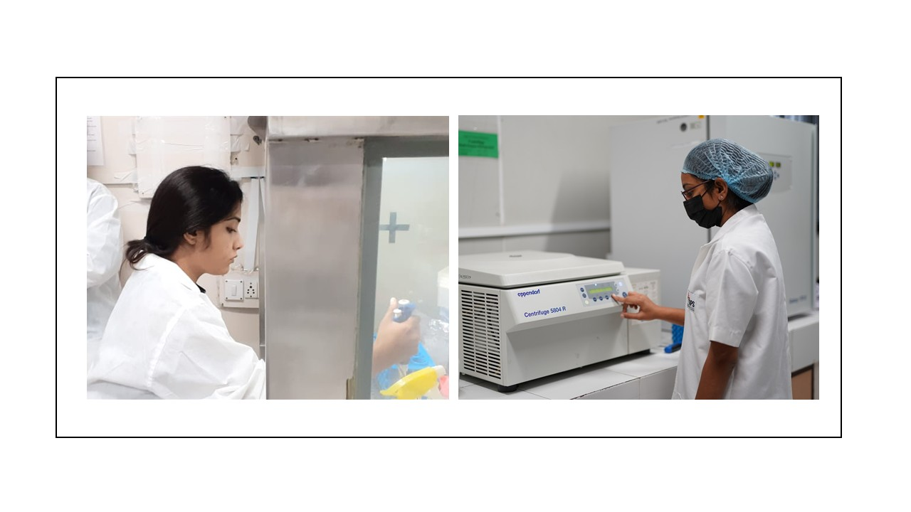
RPCP Cell Culture Laboratory Facility

The RPCP Cell Culture Laboratory Facility is a dedicated, state-of-the-art research environment designed to support high-quality in-vitro experimentation across pharmaceutical, biomedical, and toxicological sciences. The facility offers a controlled, contamination-free workspace optimized for mammalian cell culture, enabling precise, reproducible cellular studies essential for modern drug discovery and mechanistic research.

The Cell culture lab is equipped with CO₂ incubators, Biosafety cabinet, Inverted microscope, ELISA plate reader, Automated cell counter, Cooling centrifuge, Deep fridge (-80 ̊ C). As a specialized hub for in-vitro research, the RPCP Cell Culture Laboratory strengthens the institute’s mission to foster ethical, cutting-edge, and high-impact research that advances pharmaceutical and biomedical sciences.

